**Claims Run database queries**

1. **Get CLAIM details.**

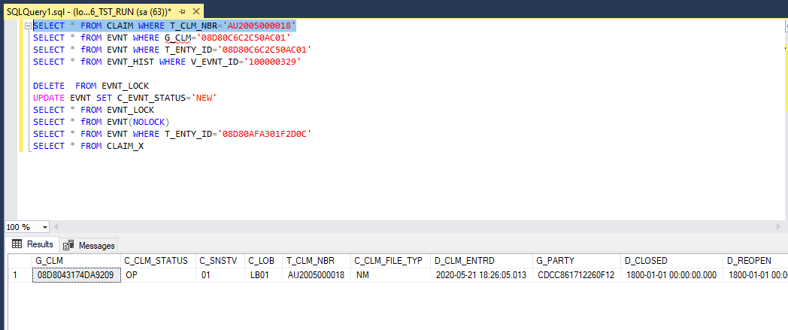

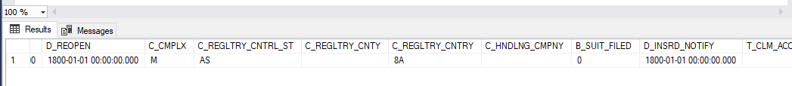

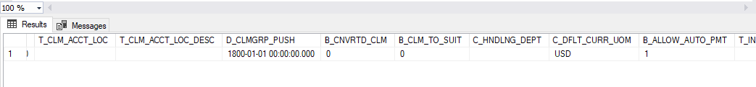

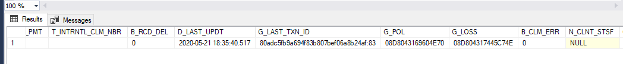

1. **Get Loss data.**

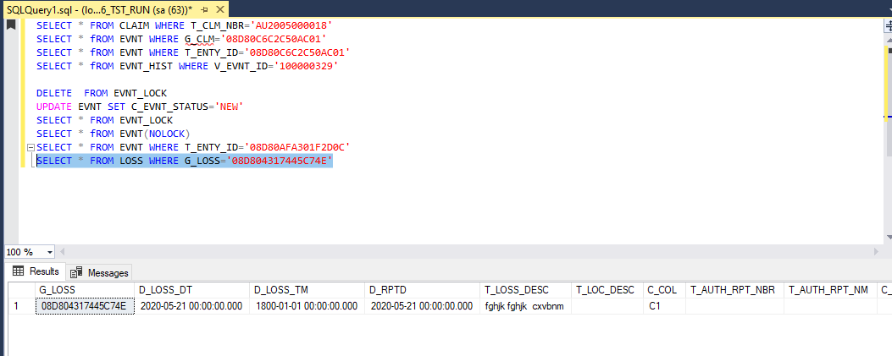

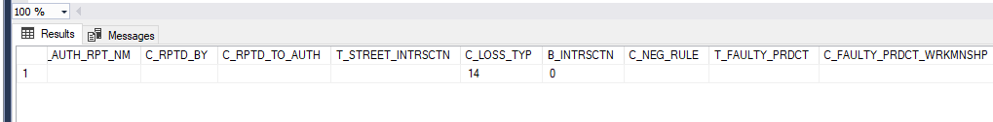

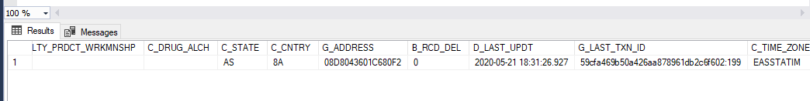

1. **Get Participants on the CLAIM.**

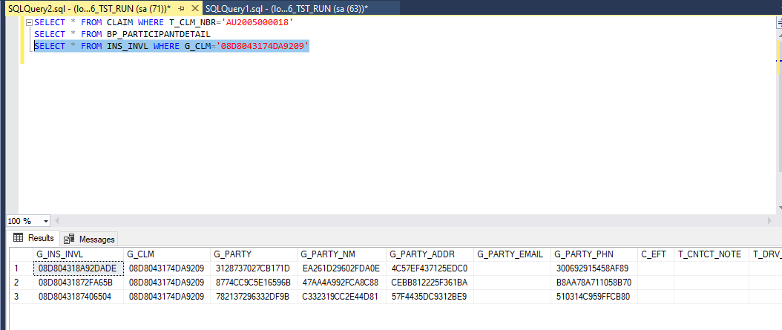

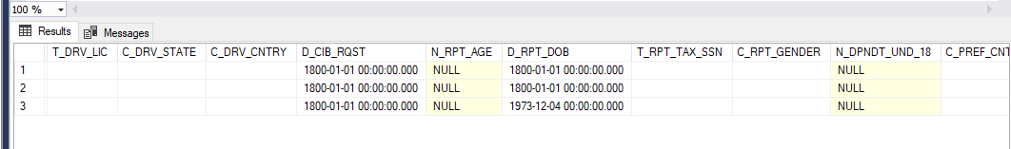

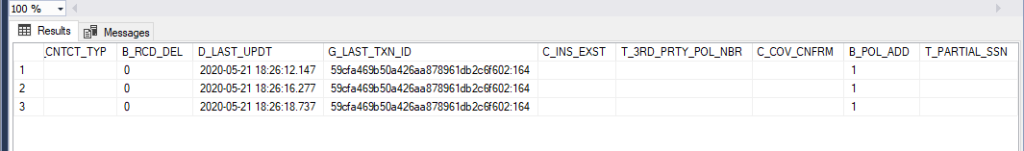

1. **Get performers on the claim**

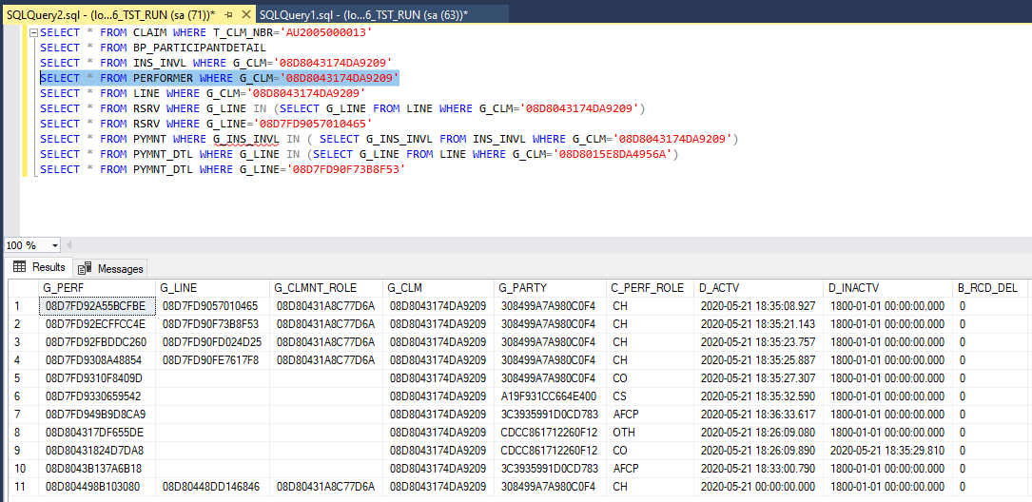

1. **List All the references table from claim table.**

**Participants**

**Policy**

**Loss**

**LOB**

**Party**

**Event**

**posted payment**

1. **Get Lines on the claim**

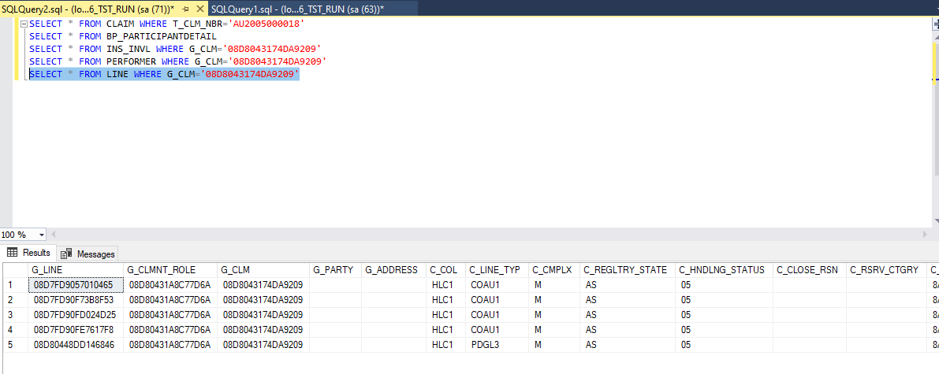

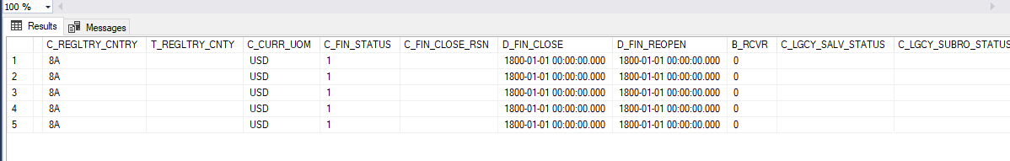

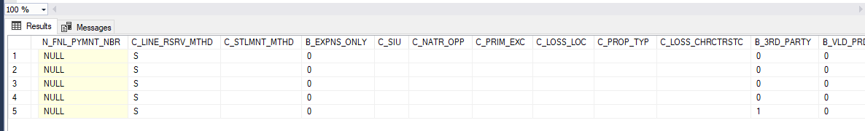

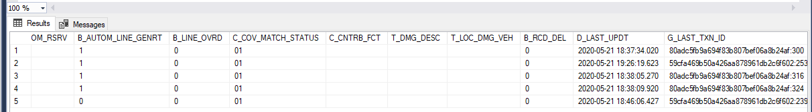

1. **Get Reserves on the claim**

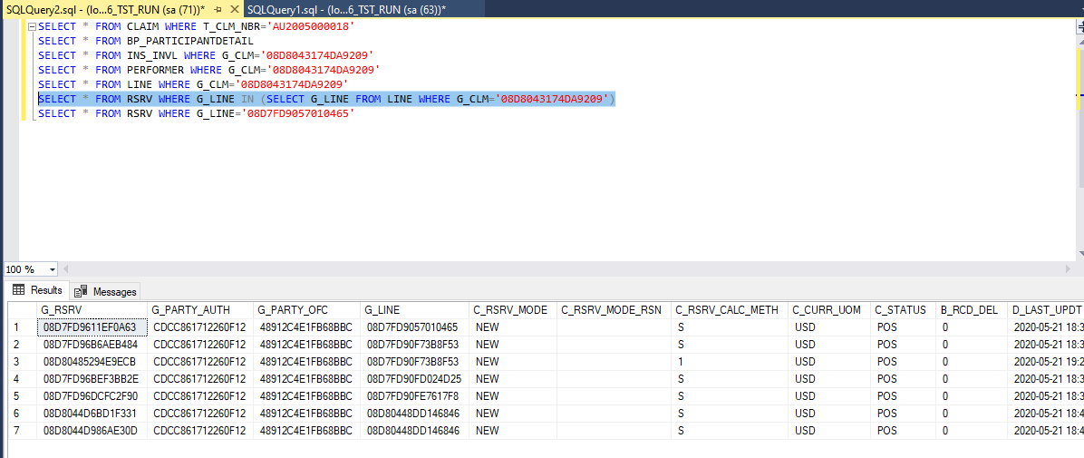

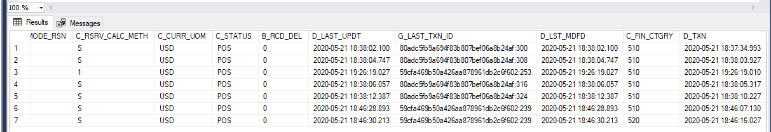

1. **Get Payment details on the claim.**

